Humpback Whales That Can Spout Fires And Rainbows? Hmm . . . . .
What is happening is that the light from the setting sun is being refracted through the jet of moist air created when the humpback whale is spoutting, resulting in what appears to be an eerie fire-like glow in the background. In order for something this mistical to occur everything has to align perfectly. The setting sun has to be at the right place when a humpback whale is spouting.
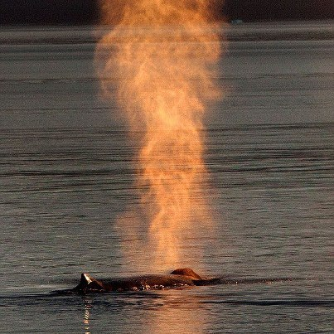It is therefore no wonder that it took amatur photographer Mark Turner days of sailing in the waters of Petersburg, Alaska to get this perfect shot. The 55-year old American who has been hooked on photography since he was seven, says that he first heard about this illusion from a professional photographer whilst on a whale watching trip. Since then, he made it his goal to capture the magical moment himself.
His patience finally paid off one evening earlier this month, when the sun was at the perfect angle and not one, but three humpback whales were froliking in the area. The best part is that he was able to capchure it on camera and share it with the rest of the world.
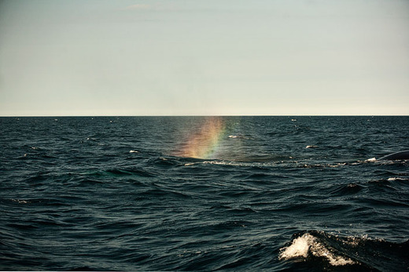Refraction can also be attributed to the rainbow shooting whale image captured by a whale watcher in 2011 in the waters off Nova Scotia. That again was an optical illusion created when the tiny water droplets in the humpback's spout bent the white light waves passing through, splitting them into seven colors - Similar to what happens when light passes through a prism.
What is interesting is that while both are examples of refraction - the bending of light waves as they encounter a medium diferent from the one they have been traveling through - the illusions created are very different.
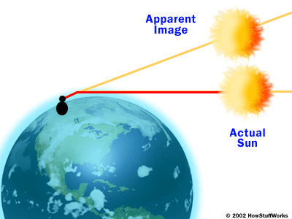The first is what we call a 'mirage' - An optical ilusion that deceives the eye into seeing something that is not there or distorting the image that is there, which in this case happens to be the setting sun. Mirages occur when light rays encounter a sudden difference in temperature as they are zooming across. In this case when hot light rays from the sun sudenly encounter the cooler air around the spray in the humpback's spout, it caused them to slow down and bend.
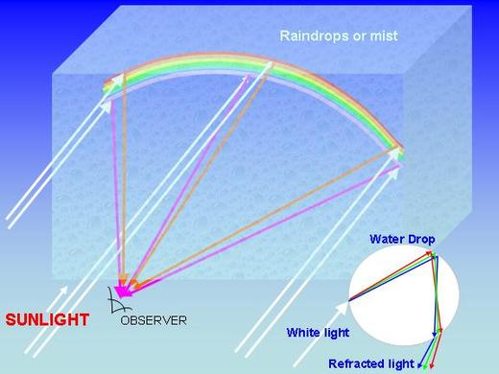The image of the rainbow spouting whale is also caused by the bending of light rays. However, in this case the angle at which the light is hitting the water droplets causes it to slow down so much that it disperses into the spectrum of seven colors. Who knew physics could be this cool!
This stunning image of a fire emanating from the spout of a humpback whale may seem like a cleverly photo shopped picture or better still, a new awesome species of the mammal. However, it is neither - Instead it is an optical illusion created by a sientific principle that you may all have heard of - Refraction.

Resources: huffpo.com, dailymail.co.uk.

