Pong - The Video Game That Started It All, Turns 40!
By Meera Dolasia on December 5, 2012
Whats even more surprising is that Allan Alcorn, the engineer who created it, had no previous gaming experience. In fact, Pong was meant to be a training exercise assigned to him by gaming company Atari's founders Nolan Bushnell and Ted Dabney. What is even more ironic is that the first commercial arcade video game 'Computer Space', which was the brainchild of Bushnell and Dabney, did not really cach the fancy of the general public.
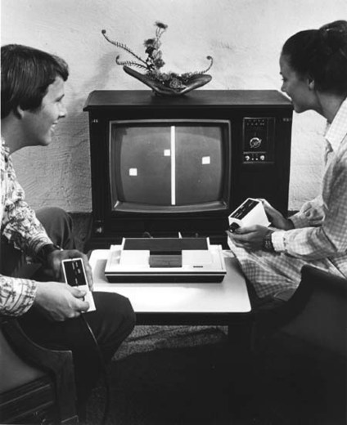Maybe it was because it was because 'Pong' was similar to a game that was already played in the real world - 'Ping Pong' or 'Table Tennis'. Just like the sport, players were asined a virtual paddle that they used to get the ball across. The game could either be played against the computer or another player.
The first version of Pong was not for home use, but instead introduced as a coin operated machine in arcades all over the country. The game became so popular that in Christmas of 1974, Atari introduced one for the home. Again, while the company is being credited with the introducing the first home video game that has paved the way for the modern-day $65 billion USD video games industry, Pong was not the pioneer here either. That honor goes to Magnavox's Odyssey who believe it or not, released their home version when Pong was still just an arcade game. But, again, it was Pong that became an instant hit, selling 150,000 units, the first holiday season it was released.
The game's popularity not only marked the beginning of today's exciting video game industry, but was also, the start of the millions of obsessed video games fans, a fact that 28-year old Okan Kaya made very evident, just last month.
The Sydney resident shattered the previous Guinness World Records of 120 hours and seven minutes of continuous gaming, by playing one for 135 hours and 50 minutes or five and half days, with only ten minute breaks every hour - His game of choice? 'Call of Duty, Black Ops 2, which also has its own record of raking in a astounding $480,000 USD for its publishers, Activision, on the first day of its release.
As for Pong? Over the years it was released in various more exciting versions and still exists online. It recently even made a cameo appearance in Disney's, Wreck It Ralph
Novmber 29th, was a landmark day for anybody that has ever touched a gaming console - That's because it was on this day, 40 years ago that Pong, the first successful commercial video game was introduced to the world.

